1. **Standards:**

**-Unit testing**

**-Static code analysis**

**-Code quality/Vulnerability**

**-Automation**

**-Reports**

**-Deployment**

1. **Once you submitted your changes to version control system (i.e. github, bitbucket, gitlab) then your CI/CD pipeline actually take place.**
2. **Jenkins is a CI/CD tool. Jenkins notify us when developer done any changes to github and as a part of automation Jenkins will run all standards mentioned in point 1. Jenkins will act as a pipe or tunnel.**
3. **Jenkins is like a orchestrator who integrate the tools for automation.**

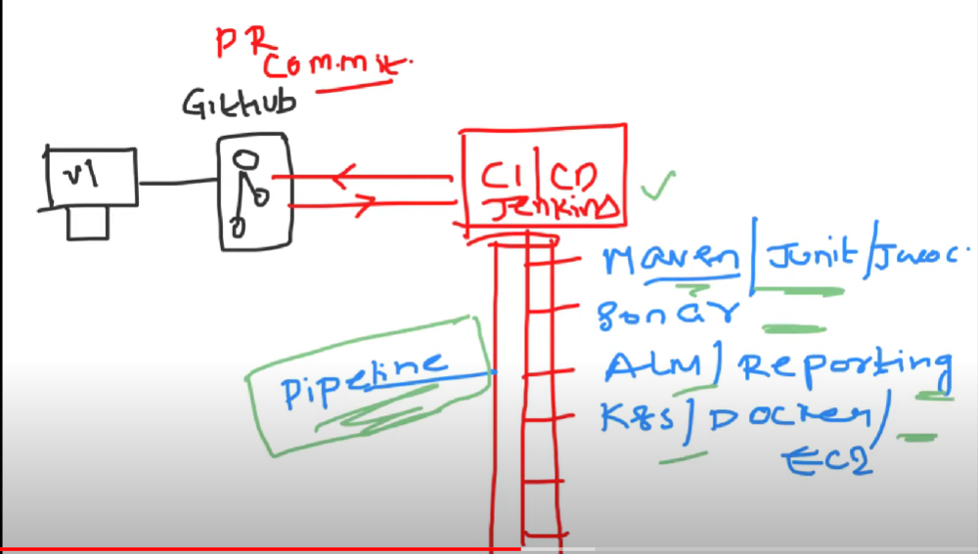

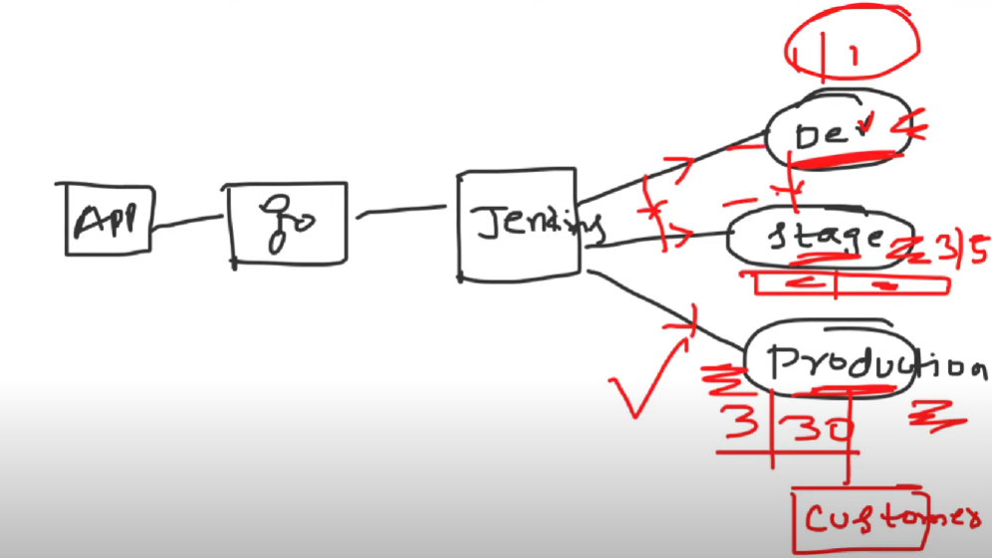

1. **Modern day CI/CD setups are done by using Kubernetes. These solutions are highly scalable.**
2. **Github action is an alternative for Jenkins.**
3. **Jenkins installation: refer below repo for detail steps**

[**https://github.com/iam-veeramalla/Jenkins-Zero-To-Hero**](https://github.com/iam-veeramalla/Jenkins-Zero-To-Hero)

1. **You can tell in interview that you have used docker as an agent in Jenkins project setup. We found this is useful in terms of cost and also in terms of efficiency.**

